1. What is Debian?
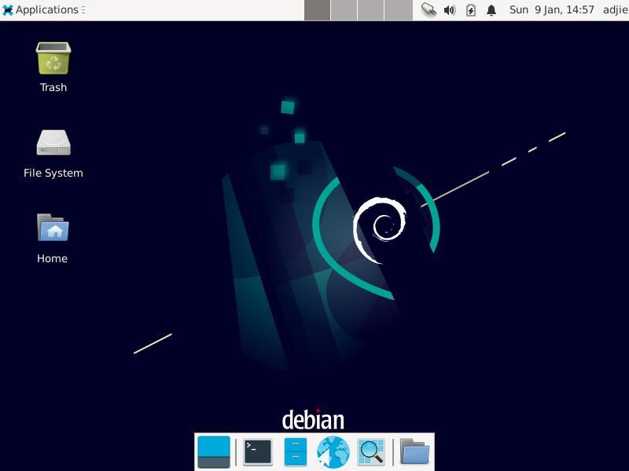
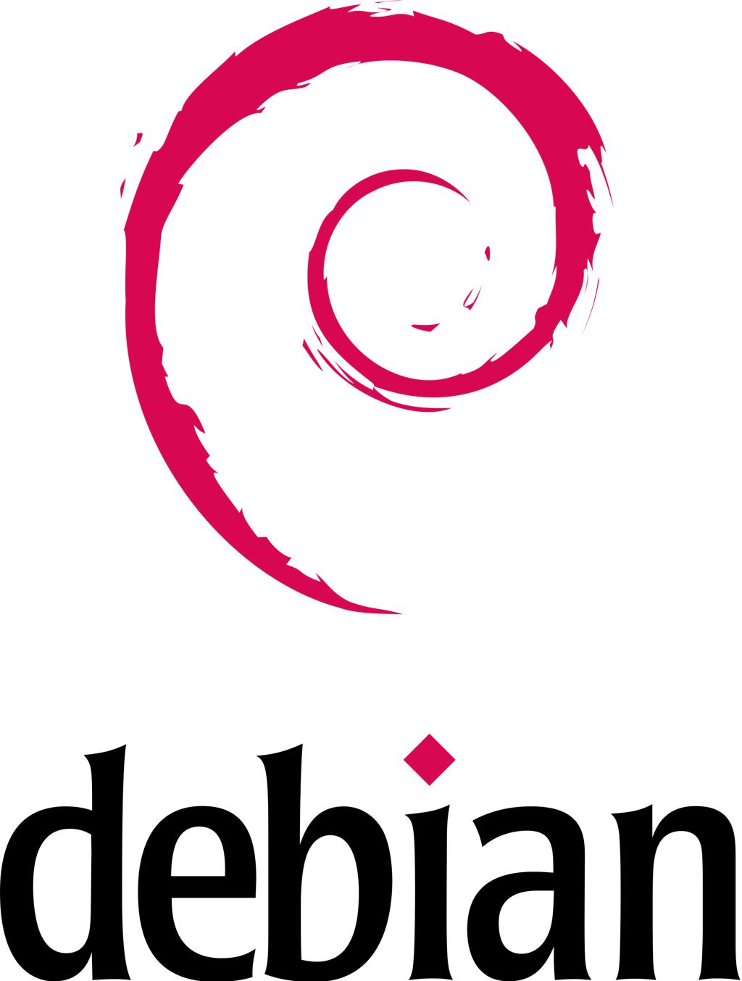
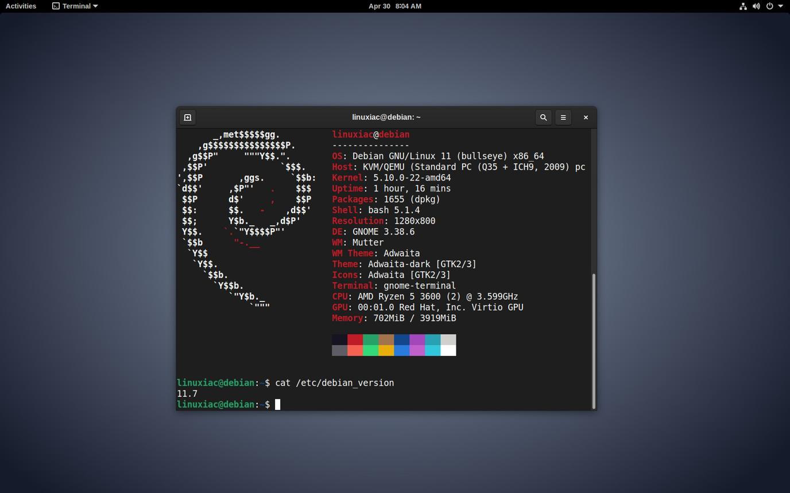
Debian is a Linux distribution (Linux distro).
Think of it this way:
Linux = the kernel
Debian = an operating system built around the Linux kernel
The Linux kernel is the core software that communicates with hardware—CPU, RAM, disks, network cards, GPUs, etc. Debian combines the Linux kernel with thousands of software packages, system utilities, package-management tools, documentation, and usually a desktop environment.
Debian describes itself as a distribution built from consistent sets of pre-compiled software packages. Its package-management system is based around APT and dpkg.
Other Linux distributions include:
- Ubuntu
- Linux Mint
- Fedora
- Arch Linux
- Rocky Linux
- Kali Linux
- openSUSE
An important relationship is:
LINUX ECOSYSTEM

Linux
Kernel
│
┌────────────────┼────────────────┐
│ │ │
Debian Fedora Arch
│
Ubuntu
│
Linux Mint
Ubuntu, for example, is based on Debian.

2. Linux vs Debian vs Windows
This distinction is extremely important.
Term | Meaning
Linux | Kernel
Debian | Linux distribution
Ubuntu | Debian-based Linux distribution
Windows | Complete operating system
macOS | Complete operating system built on Apple's Darwin/XNU technology
So comparing "Linux vs Windows" is really comparing operating-system environments, while "Debian vs Ubuntu" is comparing Linux distributions.

3. Why do developers learn Debian/Linux?
Because Linux exposes the computer in a way that is extremely convenient for development.
A developer can do things like:
cd project
python3 train.py
or:
git clone ...
cd project
python3 -m venv .venv
source .venv/bin/activate
pip install -r requirements.txt
or:
ssh user@server
and work on a remote machine without needing a graphical interface.
Linux is also the dominant environment for many servers, cloud systems, containers, HPC systems, and AI infrastructure.
That's particularly relevant to AI/ML because tools such as PyTorch explicitly support Linux distributions including Debian, and Linux can use NVIDIA CUDA or AMD ROCm for GPU acceleration.

4. The most important concept: the Terminal/Shell
When you open a Debian terminal, you aren't directly "talking to Linux."
You are talking to a shell.
For example:
You
│
▼
Terminal
│
▼
Bash
│
▼
Linux kernel
│
▼
Hardware
Terminal = the application/window.
Shell = program that interprets your commands.
Bash = one popular shell.
For example:
ls
Bash interprets this command and asks the operating system to list directory contents.
Other shells include:
- bash
- sh
- zsh
- fish

5. The Linux filesystem
Windows commonly starts you thinking:
C:\
D:\
E:\
Linux instead has one filesystem tree:
/
├── bin
├── boot
├── dev
├── etc
├── home
│ ├── alice
│ └── bob
├── lib
├── media
├── mnt
├── opt
├── proc
├── root
├── tmp
├── usr
└── var
The / is called the root of the filesystem.
Your personal directory might be:
/home/rashid
and:
~
is shorthand for your home directory.
So:
cd ~
means:
Go to my home directory.
Linux's filesystem, permissions, /proc, /sys, devices, links, etc. are fundamental concepts covered extensively in the Debian documentation.

6. pwd — Where am I?
pwd means:
Print Working Directory
pwd
Example:
/home/rashid/projects
It tells you your current location.
Think:
Windows Explorer:
"What folder am I currently inside?"

Linux:
pwd

7. cd — Change directory
cd folder
Example:
cd Documents
Go into Documents.
Go up one level:
cd ..
Go home:
cd ~
Go to the filesystem root:
cd /
Go back to the previous directory:
cd -
A very useful combination:
pwd
ls
cd project
pwd

8. ls — List files
ls
Example:
Documents
Downloads
Pictures
project
test.py
Useful versions:
ls -l
Long listing.
ls -a
Show hidden files.
ls -la
Show everything with details.
You will frequently use:
ls -lah
where:
- l = long format
- a = all files
- h = human-readable sizes

9. Hidden files
Linux filenames beginning with . are normally hidden:
.bashrc
.git
.env
.config
That's why:
ls
might not show .git.
Use:
ls -a
to see them.
This becomes very important in programming.
For example:
project/
├── .git/
├── .gitignore
├── .env
├── requirements.txt
└── train.py

10. cat — Read a file
cat filename
Example:
cat hello.txt
If:
hello.txt
contains:
Hello Linux
then:
cat hello.txt
prints:
Hello Linux
cat can also combine files:
cat file1.txt file2.txt

11. less and more
Suppose you have a huge log file:
cat huge.log
That could dump thousands of lines onto your screen.
Instead:
less huge.log
You can scroll through it.
Useful:
Space next page
b previous page
↑ ↓ move
q quit
more is another pager:
more huge.log
Generally, learn less because it is more capable.

12. head
Show the beginning of a file:
head file.txt
First 10 lines by default.
head -n 20 file.txt
First 20 lines.
For ML, this becomes useful with datasets:
head data.csv
You can quickly inspect the beginning of a dataset.

13. tail
You didn't list tail, but you should learn it.
tail logfile.txt
Shows the end of a file.
Very useful:
tail -f server.log
This continuously displays new lines being added to a log.
For example, while training an ML model:
tail -f training.log
can let you watch the training process.

14. mkdir — Create directories
mkdir project
Creates:
project/
Create nested directories:
mkdir -p project/data/raw
The -p creates parent directories when necessary.

15. touch — Create a file
touch test.txt
Creates an empty file if it doesn't exist.
You might do:
touch train.py
Then edit it.

16. nano — Simple terminal editor
nano train.py
This opens a simple text editor inside the terminal.
You can write:
print("Hello Linux")
Then:
Ctrl + O save
Ctrl + X exit
nano is excellent when you're learning Linux.
Later you may encounter:
- Vim
- Neovim
- Emacs

17. cp — Copy
cp file.txt backup.txt
Copies:
file.txt → backup.txt
Copy a directory:
cp -r project project_backup
-r means recursively.

18. mv — Move or rename
Move:
mv file.txt Documents/
Rename:
mv old.txt new.txt
This is why mv has two common purposes:
move
+
rename

19. rm — Remove
rm file.txt
Delete a file.
Directory:
rm -r project
Be careful.
Linux normally doesn't give you the same recycle-bin protection you'd expect from a GUI.
Especially dangerous:
rm -rf
-r = recursive.
-f = force.
Never blindly execute commands containing:
sudo rm -rf ...
Understand exactly what the path means first.

20. rmdir
rmdir empty_folder
Removes an empty directory.
If the directory contains files, rmdir won't remove it.
That's one difference from:
rm -r directory

21. sudo
sudo means approximately:
Execute this command with elevated privileges.
For example:
sudo apt update
Your normal user doesn't necessarily have permission to modify system files.
sudo temporarily gives the command administrative privileges if your account is authorized.
Think:
Normal user
│
│ sudo
▼
Administrator privileges
Don't think of sudo as "Linux magic."
It is fundamentally about permissions and privilege.

22. Linux permissions
Run:
ls -l
You might see:
-rwxr-xr-- 1 user user 1234 Sep 2 train.py
The first section:
-rwxr-xr--
represents permissions.
There are three major groups:
owner group others
↓ ↓ ↓
rwx r-x r--
And:
r = read
w = write
x = execute

23. chmod
chmod means:
Change mode/permissions.
For example:
chmod +x script.sh
makes a script executable.
Then:
./script.sh
can execute it.
Another common form:
chmod 755 script.sh
means approximately:
Owner: read + write + execute
Group: read + execute
Others: read + execute
The number system is based on:
r = 4
w = 2
x = 1
Therefore:
7 = 4+2+1 = rwx
5 = 4+1 = r-x
4 = 4 = r--
So:
chmod 755 script.sh
means:
rwx r-x r-x

24. man — Manual pages
One of the most important Linux commands:
man ls
You get documentation for ls.
Try:
man chmod
man cp
man mv
man ps
man kill
This is one of the reasons Linux is powerful for developers:
The operating system itself has extensive command-line documentation.
Debian maintains extensive official documentation, including the Debian Reference and package-management guides.

25. Redirection — extremely important
This is one of the most important concepts in Linux.
Suppose:
echo "Hello"
prints:
Hello
You can redirect the output into a file:
echo "Hello" > hello.txt
Now:
cat hello.txt
gives:
Hello
> means:
Redirect output into a file.
Be careful:
echo "New" > hello.txt
replaces the previous contents.

>>
Append instead:
echo "Another line" >> hello.txt
Now the file contains both.
So:
> overwrite
>> append

26. Input redirection
You can also redirect input:
command < file.txt
This tells the command to read its input from the file.

27. Pipes |
You didn't explicitly list pipes, but you absolutely need them to understand Linux.
Example:
ls | less
The output from ls becomes the input to less.
Think:
ls
│
│ output
▼
less
Another:
ps aux | less
Or:
cat logfile.txt | grep error
Now you're starting to see the philosophy of Unix/Linux:
Small programs do one job and can be combined together.

28. alias
An alias gives a command another name.
For example:
alias ll='ls -lah'
Now:
ll
is equivalent to:
ls -lah
You might create:
alias gs='git status'
Then:
gs
runs:
git status
Aliases are usually stored in shell configuration such as:
~/.bashrc

29. bash and sh
Run:
bash
to start a Bash shell.
Run:
sh
to start a shell compatible with the POSIX sh interface.
Important:
Bash ≠ Linux
Linux is the kernel.
Bash is a shell.
You can have Linux without Bash.

30. ps — Processes
A process is a running program.
For example:
python train.py
creates a running Python process.
Use:
ps
to see processes associated with your shell.
More commonly:
ps aux
shows a broader list.
You might see:
USER PID CPU MEM COMMAND
root 1 ... ... systemd
user 1234 ... ... python train.py

31. PID
Every process has a PID:
Process ID
Example:
python train.py
PID = 1234
This becomes important when controlling processes.

32. kill
Despite the name, kill doesn't necessarily mean "destroy immediately."
It sends a signal to a process.
For example:
kill 1234
asks process 1234 to terminate using the default signal.
You may encounter:
kill -9 1234
SIGKILL is much more forceful.
Don't make kill -9 your default solution. Graceful termination is preferable when possible because applications may need to clean up resources.

33. shutdown
Shutdown the machine:
sudo shutdown now
Schedule shutdown:
sudo shutdown +10
Meaning:
Shut down in 10 minutes.

34. Restart
You can reboot:
sudo reboot
or:
sudo shutdown -r now
where:
-r = reboot

35. dpkg
Now we reach one of the most important Debian concepts.
Debian packages generally use:
.deb
For example:
some-program.deb
dpkg is the low-level Debian package management tool.
For example:
sudo dpkg -i package.deb
installs a local .deb.
Check whether a package is installed:
dpkg -l
Find files installed by a package:
dpkg -L package-name
Debian's documentation describes dpkg as the lowest-level package-management tool and warns that it does not automatically handle dependencies the way APT does.

36. apt — much more important for everyday Debian use
This is where many beginners become confused.
You have:
Package management

APT
│
▼
dpkg
│
▼
.deb packages
Think:
dpkg = low-level package installer/database.
APT = higher-level package-management system that obtains packages from repositories and resolves dependencies.
Debian recommends apt for interactive command-line package management.

37. What is a repository?
Instead of manually downloading:
program.deb
you can tell Debian:
sudo apt install python3
APT contacts configured repositories.
Conceptually:
Your computer
│
│ apt
▼
Debian repository
│
├── package
├── dependencies
├── metadata
└── updates
APT figures out dependencies and downloads the appropriate packages.
This is one of Linux's biggest advantages for development.

38. apt update vs apt upgrade
This distinction is very important.
apt update
sudo apt update
means:
Download the latest information about packages available from repositories.
It doesn't normally upgrade your installed packages.
Debian describes apt update as fetching repository metadata and updating the local package information.
apt upgrade
sudo apt upgrade
means:
Upgrade installed packages to newer available versions without removing packages as part of the normal upgrade operation.
So:
apt update
↓
"What updates exist?"

apt upgrade
↓
"Install those updates."
Usually:
sudo apt update
sudo apt upgrade

39. Installing software
Example:
sudo apt install git
Install Python:
sudo apt install python3
Install pip:
sudo apt install python3-pip
Install compiler tools:
sudo apt install build-essential

40. Removing software
sudo apt remove package-name
Remove package and configuration files:
sudo apt purge package-name
Remove unnecessary dependencies:
sudo apt autoremove
Debian documents remove, purge, autoremove, clean, upgrade, and full-upgrade as standard APT operations.

41. apt full-upgrade
You may encounter:
sudo apt full-upgrade
This allows APT to make dependency changes that may involve removing or installing packages in order to complete the upgrade.
Don't confuse:
apt update
with:
apt upgrade
or:
apt full-upgrade

42. The entire package system
Here's the mental model you should memorize:
INTERNET
│
▼
Debian repositories
│
▼
APT
┌──────┴──────┐
│ │
dependencies packages
│ │
└──────┬──────┘
▼
dpkg
│
▼
installed files
This is much more useful than memorizing individual commands.

43. A realistic Debian workflow
Imagine you're starting an ML project.
First:
sudo apt update
sudo apt upgrade
Install development tools:
sudo apt install git python3 python3-pip python3-venv build-essential
Create project:
mkdir ml-project
cd ml-project
Check location:
pwd
Create environment:
python3 -m venv .venv
Activate:
source .venv/bin/activate
Install packages:
pip install numpy pandas matplotlib
Create Python file:
touch train.py
Edit:
nano train.py
Run:
python3 train.py
Check processes:
ps aux
That's a very typical Linux development workflow.

44. Why Linux can feel faster than Windows
This requires an important correction:
Linux is not inherently faster than Windows in every situation.
Performance depends on:
- hardware
- filesystem
- desktop environment
- drivers
- applications
- background services
- workload
- configuration
- power management
A carefully configured Windows installation can outperform a poorly configured Linux installation for some workloads.
But Linux can feel significantly lighter on the same hardware.
Why?
44.1 Less desktop overhead
A minimal Linux installation can run without a graphical interface at all.
For example:
Linux server
│
├── kernel
├── services
└── terminal
No desktop environment is necessary.
A Windows desktop system generally has a much larger integrated graphical operating environment.

45. Linux gives you more control
You can choose:
No GUI
XFCE
LXQt
GNOME
KDE
etc.
You can run a very minimal Debian installation.
This is especially useful for:
- servers
- cloud machines
- containers
- development machines
- embedded systems
- AI servers

46. Linux process philosophy
Unix/Linux systems have a long tradition of small tools that can be combined.
For example:
ps aux | grep python
This means:
ps
↓
process information

|
↓

grep
↓
filter lines containing "python"
You can build complex workflows from simple commands.
This philosophy is extremely useful for programmers.

47. Why Linux is particularly important for AI/ML
This is where the difference becomes especially interesting.
A typical AI development stack might look like:
Hardware
│
▼
NVIDIA GPU
│
▼
GPU Driver
│
▼
CUDA
│
▼
PyTorch / TensorFlow
│
▼
Python
│
▼
Your ML model
Linux is extremely common throughout this ecosystem.
NVIDIA provides dedicated CUDA installation/documentation for Linux, including package-manager-based installation and compiler/toolchain integration.
PyTorch officially supports both Linux and Windows, so it is not true that AI simply cannot be done on Windows.
The advantage of Linux is more about the development ecosystem and environment consistency.

48. Why ML developers often prefer Linux
Imagine you're working with:
Python
CUDA
cuDNN
PyTorch
TensorFlow
Docker
Git
SSH
C++
CMake
gcc
NVIDIA drivers
Jupyter
PostgreSQL
Redis
Kubernetes
Linux naturally exposes these tools through:
terminal
package managers
shell scripts
environment variables
filesystem permissions
SSH
process management
containers
You can install something like:
sudo apt install build-essential
and get a conventional compilation environment.
You can use:
gcc
g++
make
cmake
directly.

49. Servers are a huge reason
Suppose you develop an AI model on your laptop.
Eventually you might run it on:
AWS
Azure
Google Cloud
NVIDIA GPU server
university cluster
company server
Kubernetes cluster
A large proportion of these environments are Linux-based.
So learning Linux locally gives you skills that transfer directly to remote servers.
You can connect using:
ssh user@server
Then:
cd project
python3 train.py
You don't need to sit in front of the server.

50. SSH is incredibly important
Suppose your laptop has:
RTX 4060
but your university/company has:
8 × powerful NVIDIA GPUs
You can SSH into the server:
ssh username@server
Then run your training there.
You might use:
nvidia-smi
to inspect the GPU.
Then:
python train.py
Your local computer becomes essentially a remote control.
This is one reason Linux knowledge is so valuable for ML engineers.

51. Containers
Another huge reason is Docker.
A modern ML workflow frequently looks like:
Your computer
│
▼
Docker
│
▼
Linux container
│
├── Python
├── CUDA libraries
├── PyTorch
├── dependencies
└── application
Containers make environments reproducible.
For example:
Developer A
│
▼
same container
│
▼
Developer B
│
▼
same dependencies
Linux's process, filesystem, namespaces, permissions, and resource-control mechanisms are foundational concepts here.

52. Why macOS is popular with developers
Linux isn't the only developer-friendly platform.
macOS has another major advantage:
macOS
│
└── Unix/POSIX-style environment
So developers get:
Terminal
ssh
git
python
shell scripting
Unix utilities
while also getting Apple's polished desktop environment.
This makes macOS popular with:
- web developers
- software engineers
- mobile developers
- designers
- researchers

53. Linux vs macOS for AI
There's an important distinction.
For general software development, macOS can be excellent.
For serious NVIDIA GPU-based ML, Linux is often the more natural environment because NVIDIA's CUDA ecosystem is designed around NVIDIA GPUs, and CUDA provides separate Linux and Windows installation paths.
Modern Apple Silicon Macs instead have Apple's own GPU architecture and ML acceleration stack.
So:
General development
↓
macOS = excellent
Linux = excellent

NVIDIA CUDA ML
↓
Linux = especially strong

Windows
↓
also capable, especially with modern tooling

54. Where Windows is actually better
Don't turn Linux into a religion.
Windows is excellent for:
- gaming
- Microsoft Office ecosystem
- enterprise applications
- many commercial applications
- certain hardware/software combinations
- .NET/Visual Studio workflows
- users who simply prefer Windows
And modern Windows has improved dramatically for developers.
In particular:
WSL
Windows Subsystem for Linux lets you run Linux environments inside Windows.
Conceptually:
Windows
│
▼
WSL
│
▼
Linux environment
│
▼
Bash
Python
Git
gcc
apt
etc.
So you don't necessarily have to choose:
Windows OR Linux
You can have:
Windows + Linux development environment.

55. A much better comparison
Instead of:
"Linux is faster than Windows."
Think:
Area | Linux | Windows | macOS
Server development | ⭐⭐⭐⭐⭐ | ⭐⭐⭐ | ⭐⭐
ML/AI servers | ⭐⭐⭐⭐⭐ | ⭐⭐⭐⭐ | ⭐⭐
NVIDIA CUDA | ⭐⭐⭐⭐⭐ | ⭐⭐⭐⭐ | ❌/different ecosystem
Terminal | ⭐⭐⭐⭐⭐ | ⭐⭐⭐ | ⭐⭐⭐⭐⭐
Customization | ⭐⭐⭐⭐⭐ | ⭐⭐⭐ | ⭐⭐
Gaming | ⭐⭐⭐ | ⭐⭐⭐⭐⭐ | ⭐⭐
Commercial desktop apps | ⭐⭐⭐ | ⭐⭐⭐⭐⭐ | ⭐⭐⭐⭐⭐
Unix-style tooling | ⭐⭐⭐⭐⭐ | ⭐⭐⭐ via WSL | ⭐⭐⭐⭐⭐
Low-level control | ⭐⭐⭐⭐⭐ | ⭐⭐⭐ | ⭐⭐⭐
Ease for beginners | ⭐⭐⭐ | ⭐⭐⭐⭐⭐ | ⭐⭐⭐⭐⭐
These are broad tendencies rather than absolute measurements.

56. The concepts you should learn next
Your command list is a good start, but you're missing several very important Linux concepts.
I would learn them in this order.
Level 1 — Terminal fundamentals
Learn:
pwd
cd
ls
mkdir
touch
cp
mv
rm
cat
less
head
tail
nano
man
Then:
>
>>
|
<

Level 2 — Linux filesystem
Learn:
/
├── /home
├── /etc
├── /usr
├── /var
├── /tmp
├── /opt
├── /dev
├── /proc
└── /root
Understand what each directory is for.

Level 3 — Permissions
Learn:
r
w
x
Then:
chmod
chown
chgrp
You haven't listed chown, but you should learn it.

Level 4 — Processes
Learn:
ps
top
htop
kill
killall
jobs
fg
bg
Understand:
process
PID
parent process
child process
foreground
background
signal

Level 5 — Shell
Learn:
bash
sh
.bashrc
variables
PATH
aliases
environment variables
For example:
echo $PATH

57. Environment variables
This is critical for ML.
For example:
echo $PATH
might produce something like:
/usr/local/bin:/usr/bin:/bin
When you type:
python
the shell searches those directories for the executable.
You will eventually encounter:
export CUDA_HOME=/usr/local/cuda
or:
export PATH="$PATH:/some/directory"
Understanding environment variables makes CUDA, Python, Docker, APIs, and development environments much easier to understand.

58. Python virtual environments
For ML development, learn this very early.
Suppose Project A needs:
PyTorch 2.x
and Project B needs a different version.
You don't want:
one giant global Python installation
Instead:
Project A
└── .venv
├── Python
├── NumPy
└── PyTorch

Project B
└── .venv
├── Python
├── NumPy
└── different PyTorch
Typical:
python3 -m venv .venv
source .venv/bin/activate
Then:
pip install numpy pandas torch

59. Git
You should learn Git almost immediately after basic Linux.
git clone ...
git status
git add .
git commit
git push
git pull
The typical developer environment becomes:
Linux
+
Bash
+
Git
+
Python
+
Virtual environments
+
Docker
+
IDE

60. grep
Another command missing from your list:
grep
It searches text.
Example:
grep "error" logfile.txt
Combine with pipes:
ps aux | grep python
This is an extremely important Linux skill.

61. find
Search for files:
find . -name "*.py"
Meaning:
Starting from the current directory, find Python files.
For programming projects:
find . -name "*.py"
is extremely useful.

62. which
Find which executable is being used:
which python3
For example:
/usr/bin/python3
Very useful when you have multiple Python installations.

63. echo
Print text:
echo "Hello"
Print an environment variable:
echo $PATH
Print another:
echo $HOME
This is extremely useful for shell scripting.

64. sudo + security
A beginner often learns:
sudo command
and starts using it everywhere.
Don't.
For example, you generally don't want to make your entire Python project owned by root.
Bad habit:
sudo pip install ...
Better approach:
system packages
↓
apt

project Python packages
↓
virtual environment + pip
This separation will save you a lot of problems.

65. The complete mental model
If you understand this diagram, you're starting to understand Linux:
USER
│
▼
TERMINAL
│
▼
BASH
│
┌──────────────┼──────────────┐
│ │ │
ls cd python
│ │ │
└──────────────┼──────────────┘
▼
LINUX SYSTEM CALLS
│
▼
LINUX KERNEL
┌───────────┼───────────┐
│ │ │
CPU RAM GPU
│ │ │
└───────────┼───────────┘
▼
HARDWARE
Meanwhile:
SOFTWARE INSTALLATION

Debian Repository
│
▼
APT
│
▼
dpkg
│
▼
Installed Packages
│
▼
Your applications

66. Your command cheat sheet
Command | Purpose | Example
pwd | Show current directory | pwd
cd | Change directory | cd Documents
ls | List files | ls -lah
cat | Print file | cat file.txt
less | Read large file | less log.txt
more | Page through file | more log.txt
head | Beginning of file | head data.csv
tail | End of file | tail log.txt
mkdir | Create directory | mkdir project
touch | Create file | touch test.py
cp | Copy | cp a.txt b.txt
mv | Move/rename | mv old.py new.py
rm | Delete | rm file.txt
rmdir | Delete empty directory | rmdir test
sudo | Run with privileges | sudo apt update
man | Manual | man ls
chmod | Change permissions | chmod +x script.sh
bash | Start Bash | bash
sh | Start sh | sh
alias | Create shortcut | alias ll='ls -lah'
ps | Show processes | ps aux
kill | Send signal | kill 1234
shutdown | Shutdown | sudo shutdown now
reboot | Restart | sudo reboot
dpkg | Low-level Debian package tool | dpkg -l
apt | Package management | sudo apt install git
grep | Search text | grep error log.txt
find | Find files | find . -name "*.py"
which | Locate executable | which python3
echo | Print text/variables | echo $PATH

67. Commands I'd recommend you memorize first
Don't try to memorize 50 commands simultaneously.
Start with these:
pwd
ls
cd
mkdir
touch
cp
mv
rm
cat
less
head
tail
nano
man
sudo
apt
ps
kill
chmod
grep
find
Then learn:
|
>
>>
<
&
$
These symbols are arguably as important as the commands themselves.

68. A practical exercise
If you're learning Debian, open the terminal and do this:
mkdir linux-practice
cd linux-practice

pwd

touch hello.txt

echo "Hello Debian" > hello.txt

cat hello.txt

cp hello.txt copy.txt

mv copy.txt renamed.txt

ls -lah

mkdir test

mv renamed.txt test/

ls -lah test/

cd test

pwd

cat renamed.txt

cd ..

rm -r test
You have just practiced:
pwd
cd
mkdir
touch
echo
>
cat
cp
mv
ls
rm
That's much better than simply reading definitions.

69. Then try this ML-oriented exercise
Create:
mkdir ml-project
cd ml-project

mkdir data
mkdir models
mkdir src
mkdir logs

touch src/train.py
touch src/evaluate.py
touch README.md

ls -R
Your project becomes:
ml-project/
├── data/
├── logs/
├── models/
├── README.md
└── src/
├── evaluate.py
└── train.py
This is the kind of filesystem organization you'll encounter constantly in software/ML projects.

70. The big picture
Ultimately, don't learn Debian as:
"I need to memorize commands."
Learn it as:
DEBIAN / LINUX

│
┌────────────────┼────────────────┐
│ │ │
Filesystem Processes Packages
│ │ │
/home /etc ps / kill apt / dpkg
│ │ │
permissions signals repositories
chmod/chown
│
▼
SHELL
│
┌────┼─────────────┐
│ │ │
bash pipes redirection
│ | > >>
│
▼
Applications
│
├── Python
├── Git
├── Docker
├── C/C++
├── PyTorch
└── CUDA
And that leads directly into modern AI engineering:
Linux
↓
Shell
↓
Git
↓
Python
↓
Virtual environments
↓
CUDA / ROCm
↓
PyTorch / TensorFlow
↓
Docker
↓
SSH
↓
GPU servers
↓
Cloud / Kubernetes
↓
ML / AI systems
That is the real reason Linux knowledge is so valuable for an AI/ML developer.
It isn't simply because "Linux is faster." It's because Linux gives you a native, scriptable, controllable environment that closely resembles the environments where serious software, cloud, GPU, and ML workloads are deployed. PyTorch supports both Linux and Windows, so Windows remains perfectly viable; Linux's advantage is primarily ecosystem alignment and operational familiarity rather than a universal raw-speed advantage.
Official references
- Debian Reference — broad guide to Debian, filesystem, permissions, shells, and administration.
- Debian Package Management — APT, dpkg, repositories, upgrades, dependencies.
- Debian Documentation — official documentation hub.
- PyTorch installation guide — current Linux/Windows installation and CUDA/ROCm guidance.
- NVIDIA CUDA documentation — CUDA ecosystem and Linux/Windows documentation.

